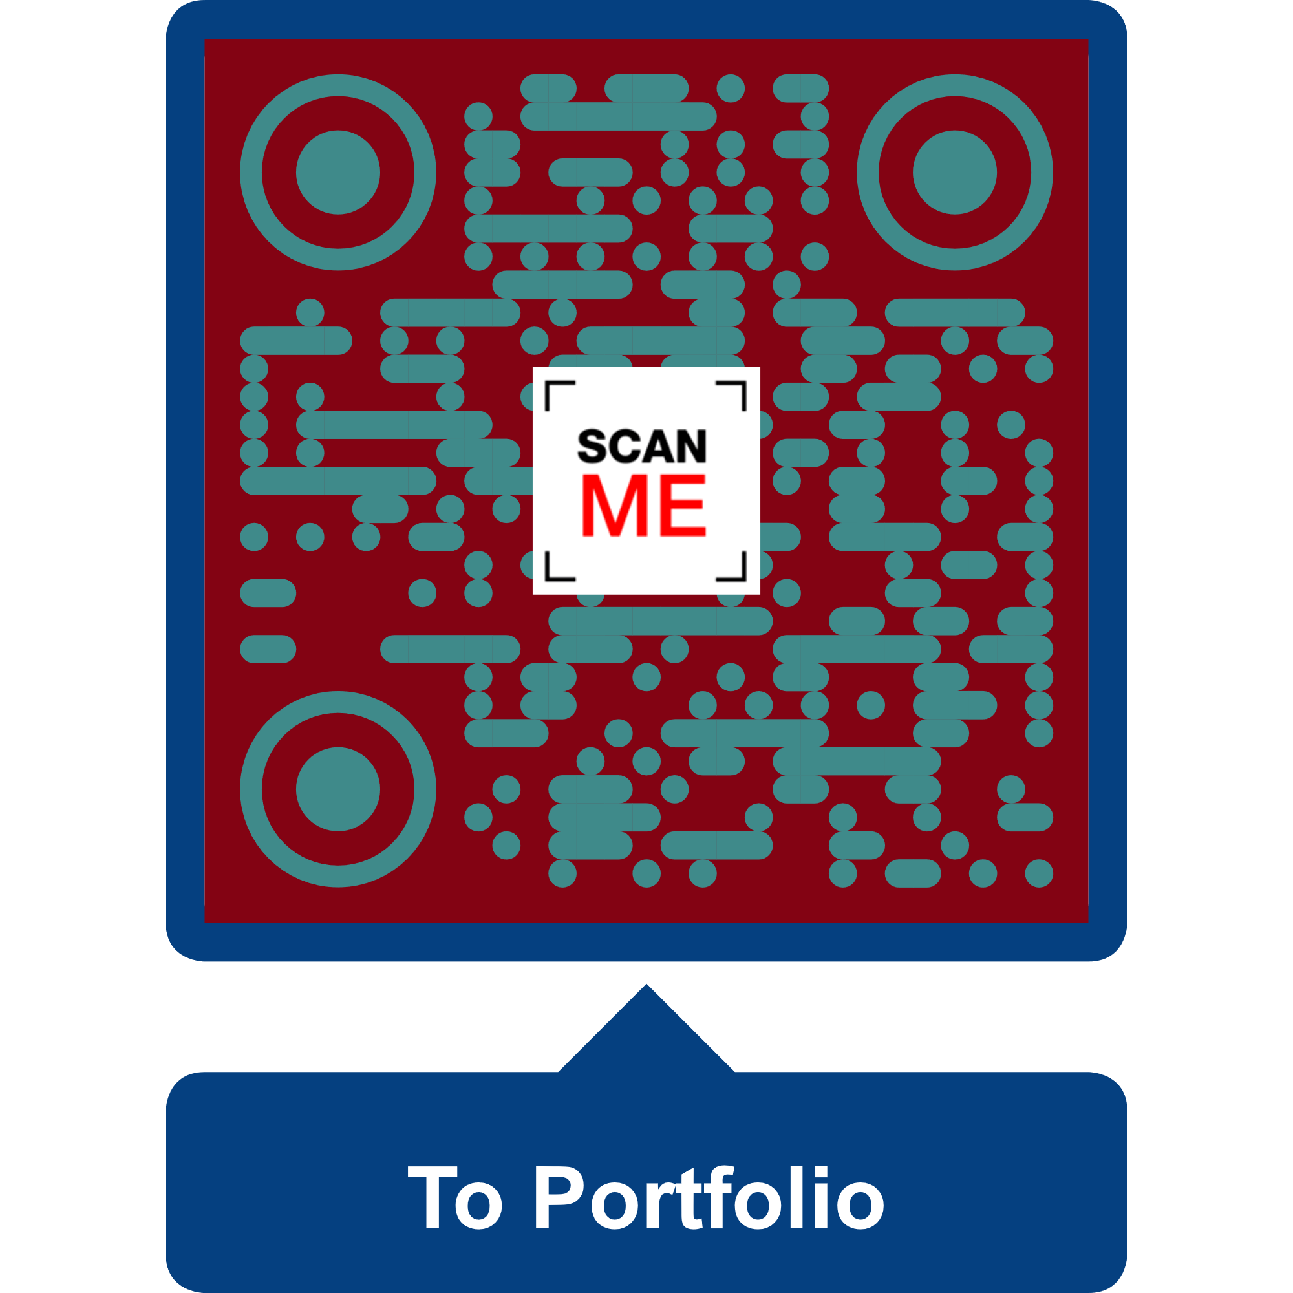

**Luke Davis Fox (NZ born)**

**Graduate Programmer**

**Te whakatinana Whakaakoranga**

**Implementing Education**

**+6421-1888876**

**foxyflow@contractor.net**

**Seeking**

Junior to Intermediate software development or software engineering position. – Programming work in New Zealand or Australia; other countries would have to provide a work-visa.

**Skills from Educational Experience**

*Within my foxyflow Github, each skill has a language-labelled coded project to see how I code* [*https://github.com/foxyflow*](https://github.com/foxyflow)

**Strong Educational Experience:**

Object-oriented programming (OOP)

* C# and .NET
* C++
* Python

**Software:**

* Unreal Engine
* Unity Software
* IDEs: Visual Studio 2019 (and PyCharm)
* Apache: WAMP
* Blockchain: Remix and Solidity

**3 Years’ Educational Experience:**

* Linux Bash
* JavaScript and ReactJS’ hooks
* API creation using NodeJS
* PHP

**Software:**

* Maya and Photoshop (3D and 2D modelling)
* Trello (Kanban and Scrum)
* Java Software (Weka (Machine Learning)
* Postman (Backend testing)
* Ubuntu on Windows (Bash)

*Software, languages, libraries, and frameworks are all tools to help produce a better product and service – I will happily adapt to what your workplace is using.*

**Portfolio**

[**https://foxyflow.github.io/Portfolio/**](https://foxyflow.github.io/Portfolio/)

**My business website:**

[**https://lukeslanguagelearning.academy**](https://lukeslanguagelearning.academy)

**for links to downloadable projects**

**How I present: A series of lesson plans teaching programming:**

[**https://tinyurl.com/LukesLessonsPlaylist**](https://tinyurl.com/LukesLessonsPlaylist)

**How I wrote a business plan:**

[**https://tinyurl.com/LukesLanguageLearningPlan**](https://tinyurl.com/LukesLanguageLearningPlan)

**Other projects**

[**https://github.com/foxyflow**](https://github.com/foxyflow)

The *lukeslanguagelearning* link contains an *Unreal* Project made with C++ and Unreal’s blueprints with over 10,000 words of agile test-driven project managed documentation. Other 2D and 3D videogame projects such as Unity3D and Universal Windows Platform (UWP) applications were created using OOP in C# .NET also available linked via my foxyflow GitHub.

**Information about myself**

I have created a series of programming videos to teach core concepts such as Object Orientated Programming (OOP) – this is taught using Python for future proofing applications because of its vast versatility in the marketplace … videos on YouTube.

I am currently creating some generated NFTs using the Solidity language, this has led me to some work and a blockchain developer – creating cryptocurrency smart-contracts in VScode, Remix, and Photoshop.

I enjoy the whole creation process of designing something from programming. EG a game, application, or website. Problem solving is very satisfying especially when it can lead to better life improvements. I have created several websites and applications over time.

Within the workforce, I have come from an applied Education and Construction background. Now that I have completed my Bachelor of Science major in Applied Computing -- a three year heavily focused programming degree in a variety of languages: including but not limited to: C# and .NET using MVC models; JavaScript using JSON APIs, NodeJs, and ReactJs; Python and Bash; and PHP with Apache’s WAMP (finished in July 2021), **I enjoy programming for a living in a team environment or remotely.**

**Additional information**

* Spare time activities: chess, guitar, skateboarding, and Italian culture.
* Holidays (before covid) in: Australia, Cook Islands, USA, UK, Italy, and China.
* Hold a current passport, full car, and learner bike licence.

**Work experience**

*Current Software work*

**Blockchain software developer** (Mid-January to current with small start-up company)

Creating smart-contracts with the Solidity language and NFTs with Photoshop.

**Software consultant Internship** (August. 2021 to December 2021 with Manaaki)

Helping small business via demonstrating and implementing current software products into their roadmaps and lifecycles.

Previous jobs – Not related to software

**Interior Plastering**

Self-employed for the last six years. *(April 2016 to current.)*

<https://foxyflow.wordpress.com/>

Foxstop Plaster Service *(2010 to March 2016.)*

***Weekend Hostel Manager***

***Brookfield Accommodation Hamilton NZ*** *(2006 to 2010 4years 4months.)*

This job required administration and management skills; organising trades; trust with money and time; Eftpos and cash-up using excel; writing reports and recommendations; eviction notices; and a range of diverse people skills.

***Barista***

*Red Cart Hamilton East (4+ years while working at Brookfield Accommodation.)*

I volunteered mornings for perfecting coffee skills with Rob at Red Cart Hamilton East for many years and remain good friends.

***Teacher***

***Ministry of Education Wellington (6 months set-time contract)***

Teaching high school Math. and English NCEA levels. *(2005.)*

***Youth Horizons Porirua Wellington* (1 year)**

Teaching with outdoor activities such as skateboarding. Ages 12 to 15 with ‘conduct disorders’ (contract with Youth Horizons Porirua Wellington) *(2004.)*

***Music Teacher***

Teaching guitar over the years to a range of children and adults. *(2001 – 2007 -- 7+ years part-time while studying.)*

**Referees**

**Character reference:**

Rob Parr: Coffee maker: +64221082847

Manaaki – please ask for the phone number.

**Programming teachers happy to be a reference:**

Andrew Chapman*:* former supervisor on <https://lukeslanguagelearning.academy/>

Project and Project Management.

[Andrew.chapman@toiohomai.ac.nz](mailto:Andrew.chapman@toiohomai.ac.nz)

Paul Morris: former GUI UI C# UWP Teacher from Manchester -- Paul worked on the first Tomb Raider game.

[paul.morris@toiohomai.ac.nz](mailto:paul.morris@toiohomai.ac.nz)

**Construction**

* Phil Wickens painter -- 02108575915
* PM building LTD Phil Murry -- 021-231-1879
* Luke Blackman, builder -- 027-6901043

**Hospitality**

Former manager at hostel. Colin Nordstrom: +6421-831-094

**Education**

***In space time***

**Creating a 2D videogame using only Python and an IDE.**

**The end result is a customisable game with a level editor to create your own puzzle games: YouTube link:**

[**https://tinyurl.com/LukesLessonsPlaylist**](https://tinyurl.com/LukesLessonsPlaylist)

Working through: Udacity’s *C++ for programmers’* course

<https://tinyurl.com/LukeFox>

Reuben Ward’s Patreon C++ Survival Game Course

<https://www.patreon.com/reubenward/posts>

Epic’s Learning Library videos

<https://learn.unrealengine.com/home/dashboard>

Coding practice:

<https://www.codecademy.com/profiles/Foxyflow>

And, a range of Udemy courses: Unreal’s blueprints; SDL2; C++ for game development.

**Current education (Finished July 2021)**

*Bachelor of Science: Major in Applied Computing (University of Waikato).*

Class representative, volunteering for these papers: Statistics for Science, Applied Computing Tools, and Advanced Database Concepts. Plus, managing and playing in the University of Waikato’s basketball team (good times).

**Former tertiary education**

* Postgraduate Certificate in Education (University of Waikato).
* Bachelor of Arts Major in Education (Victoria University of Wellington).
* Contemporary Music Certificate (Nelson School of Music).
* Teacher Aide Certificate (University of Canterbury).

**Certificates and transcripts**

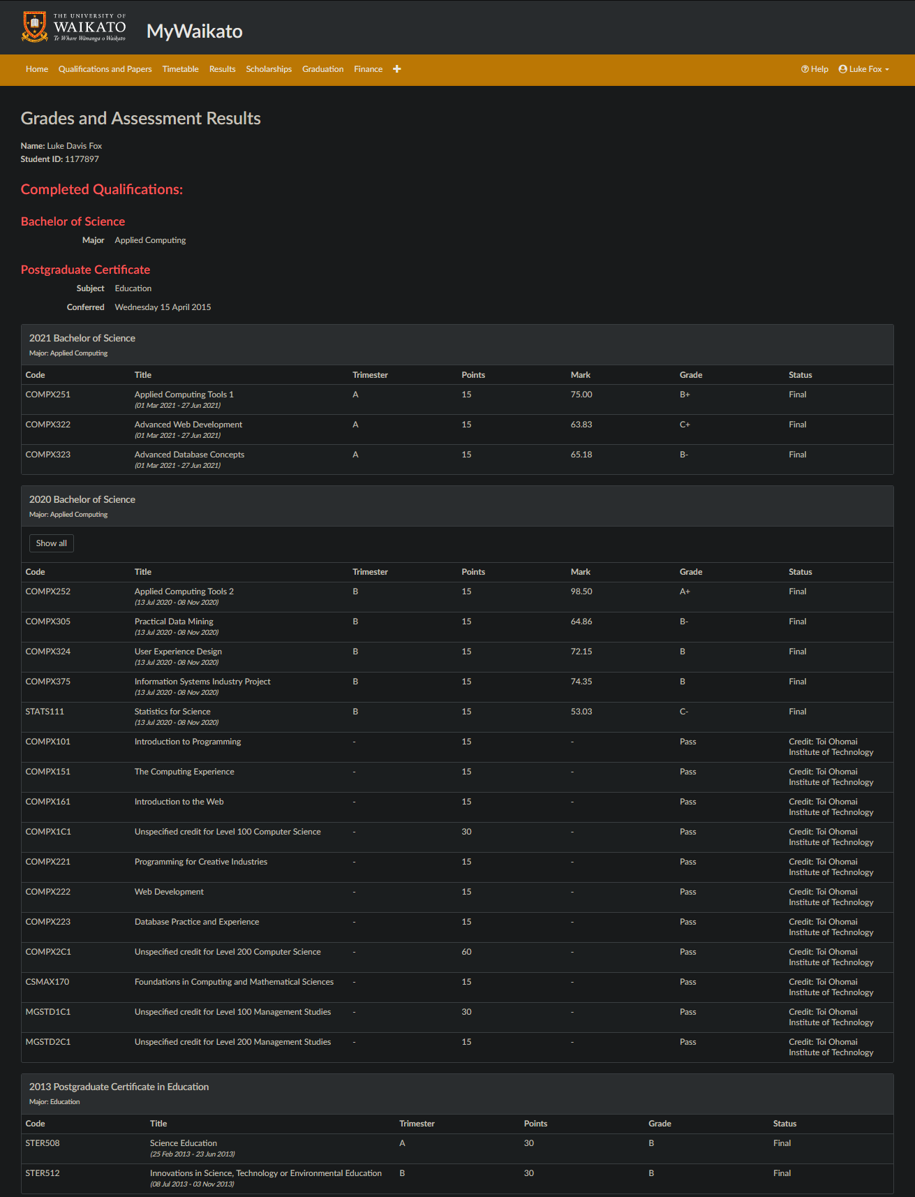

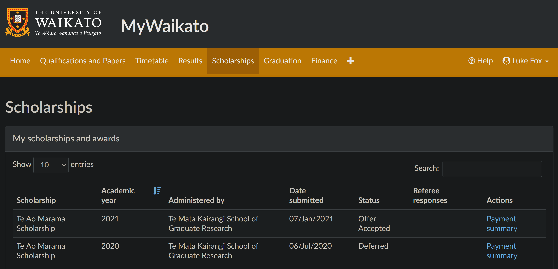

Awarded: University of Waikato’s Te Ao Marama Graduate Scholarship

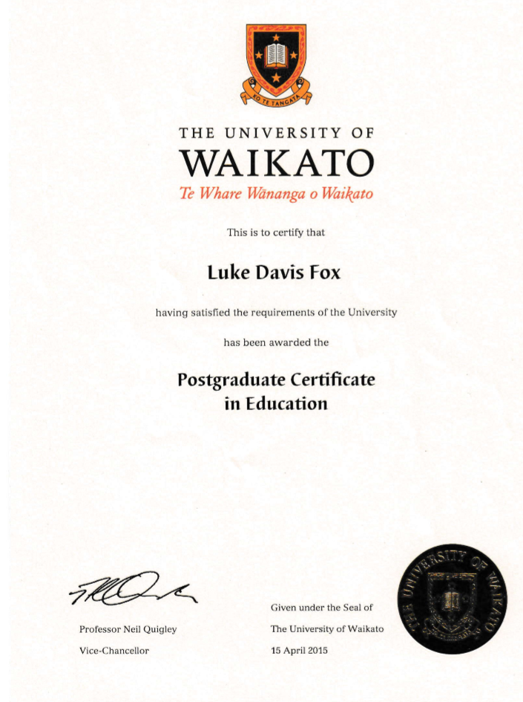

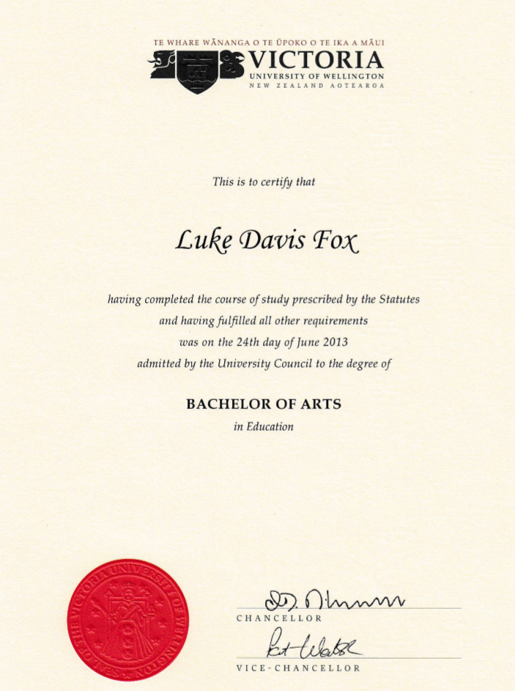

Please visit: <https://foxyflow.github.io/Portfolio> for the most up-to-date CV and projects’ information.